New Britain Youth Museum
Hungerford Nature Center
191 Farmington Ave., Kensington, CT 06037

Summer Sisters in Science 2018

Empowering girls with STEAM, nature & sisterhood!
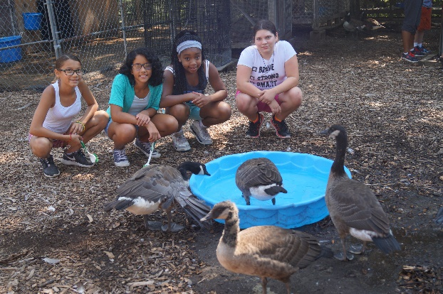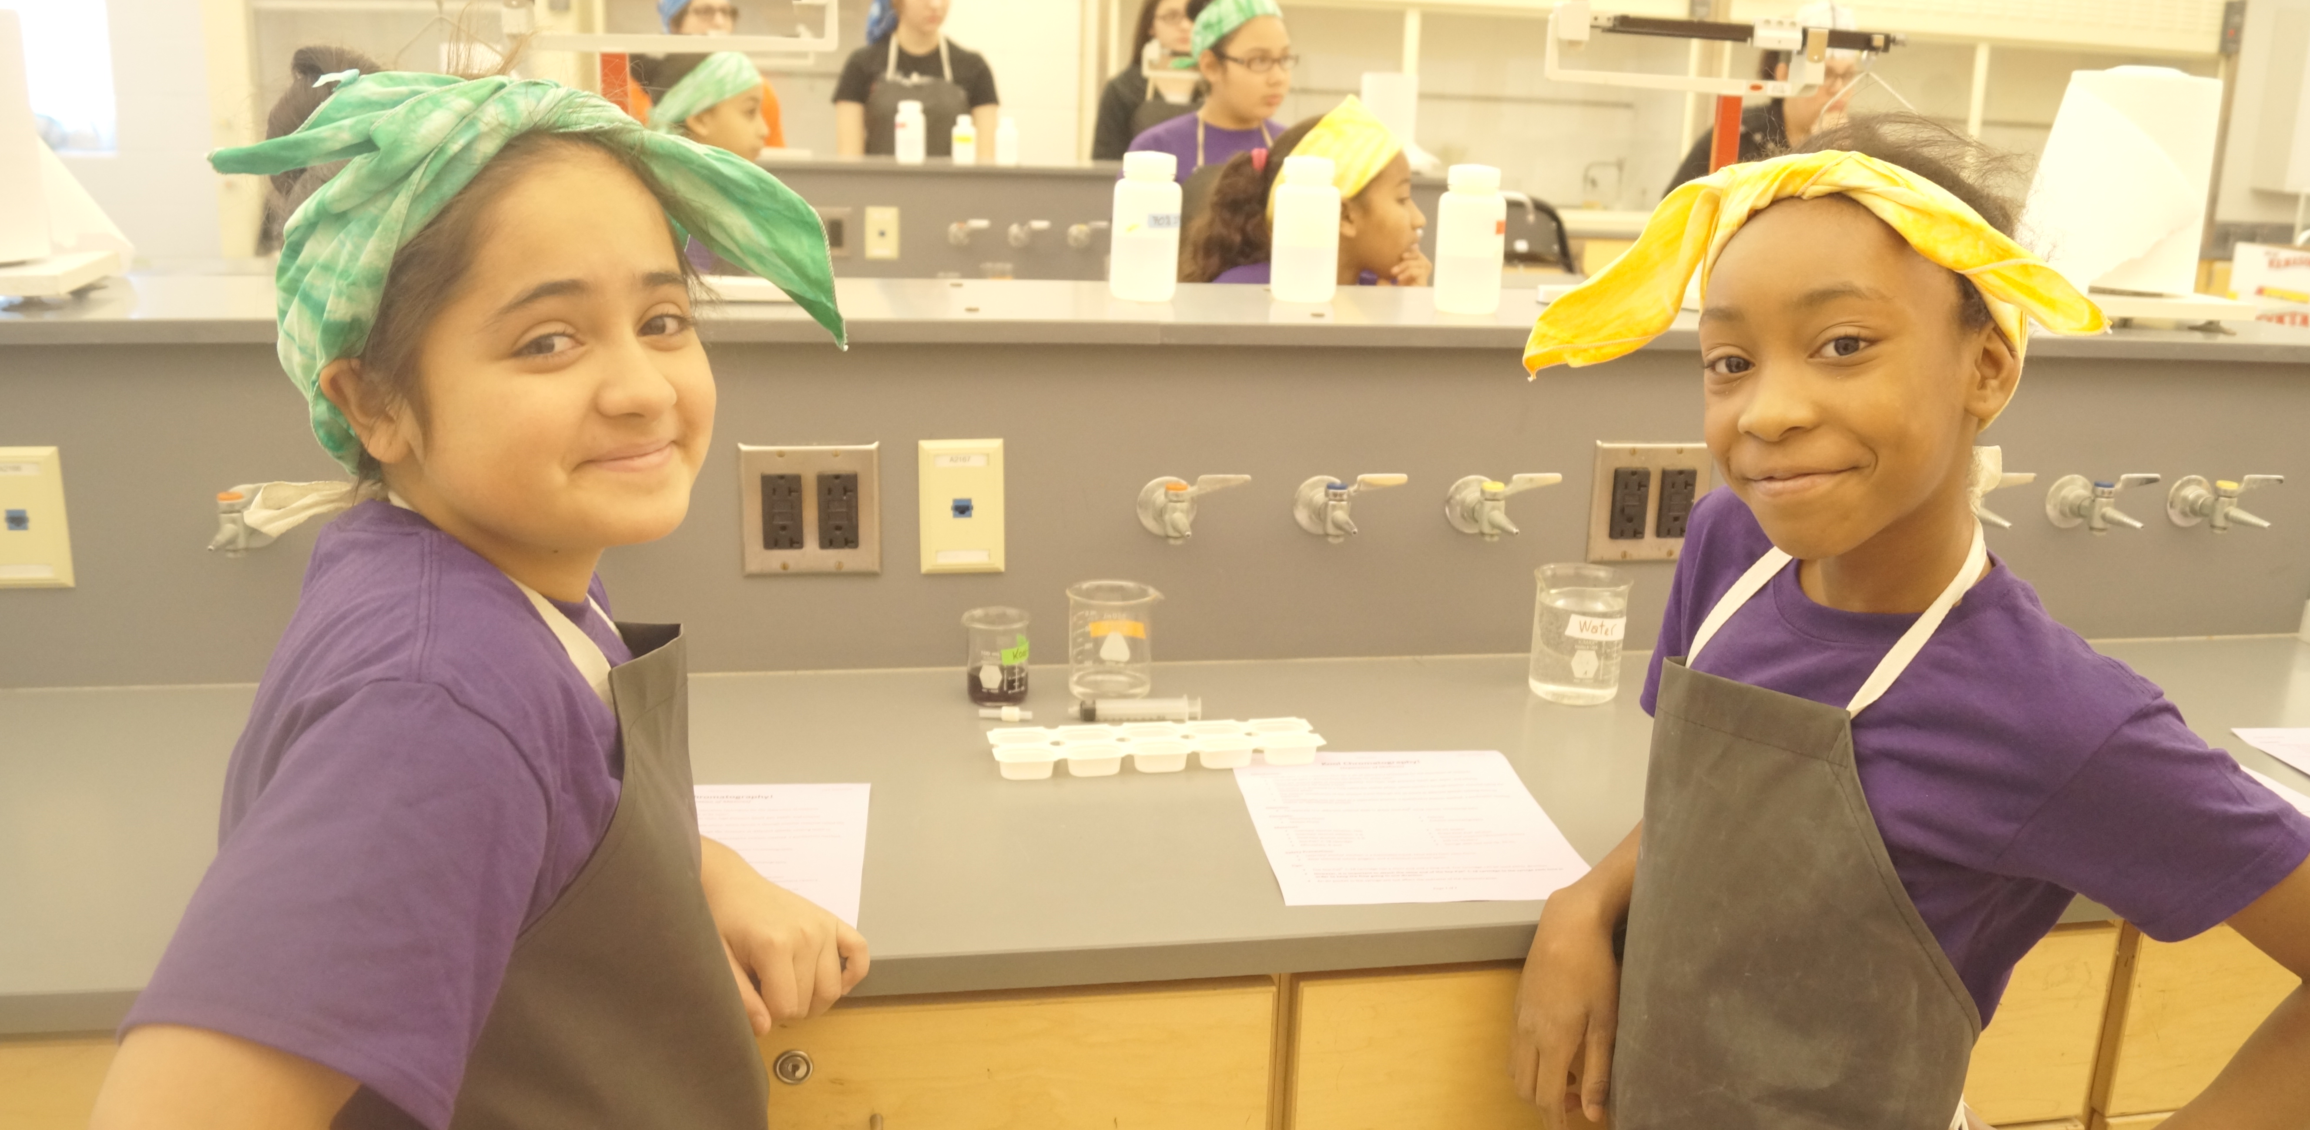
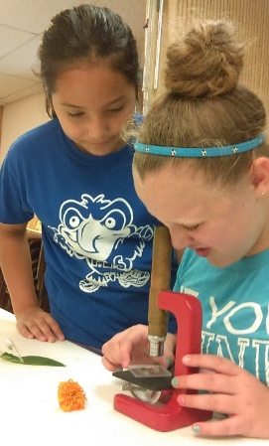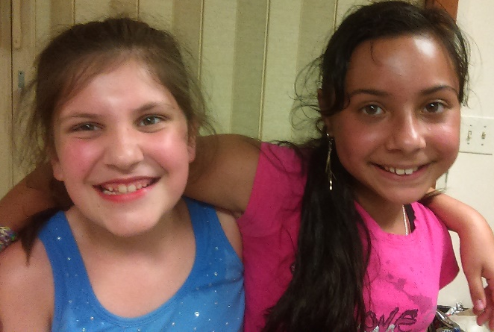
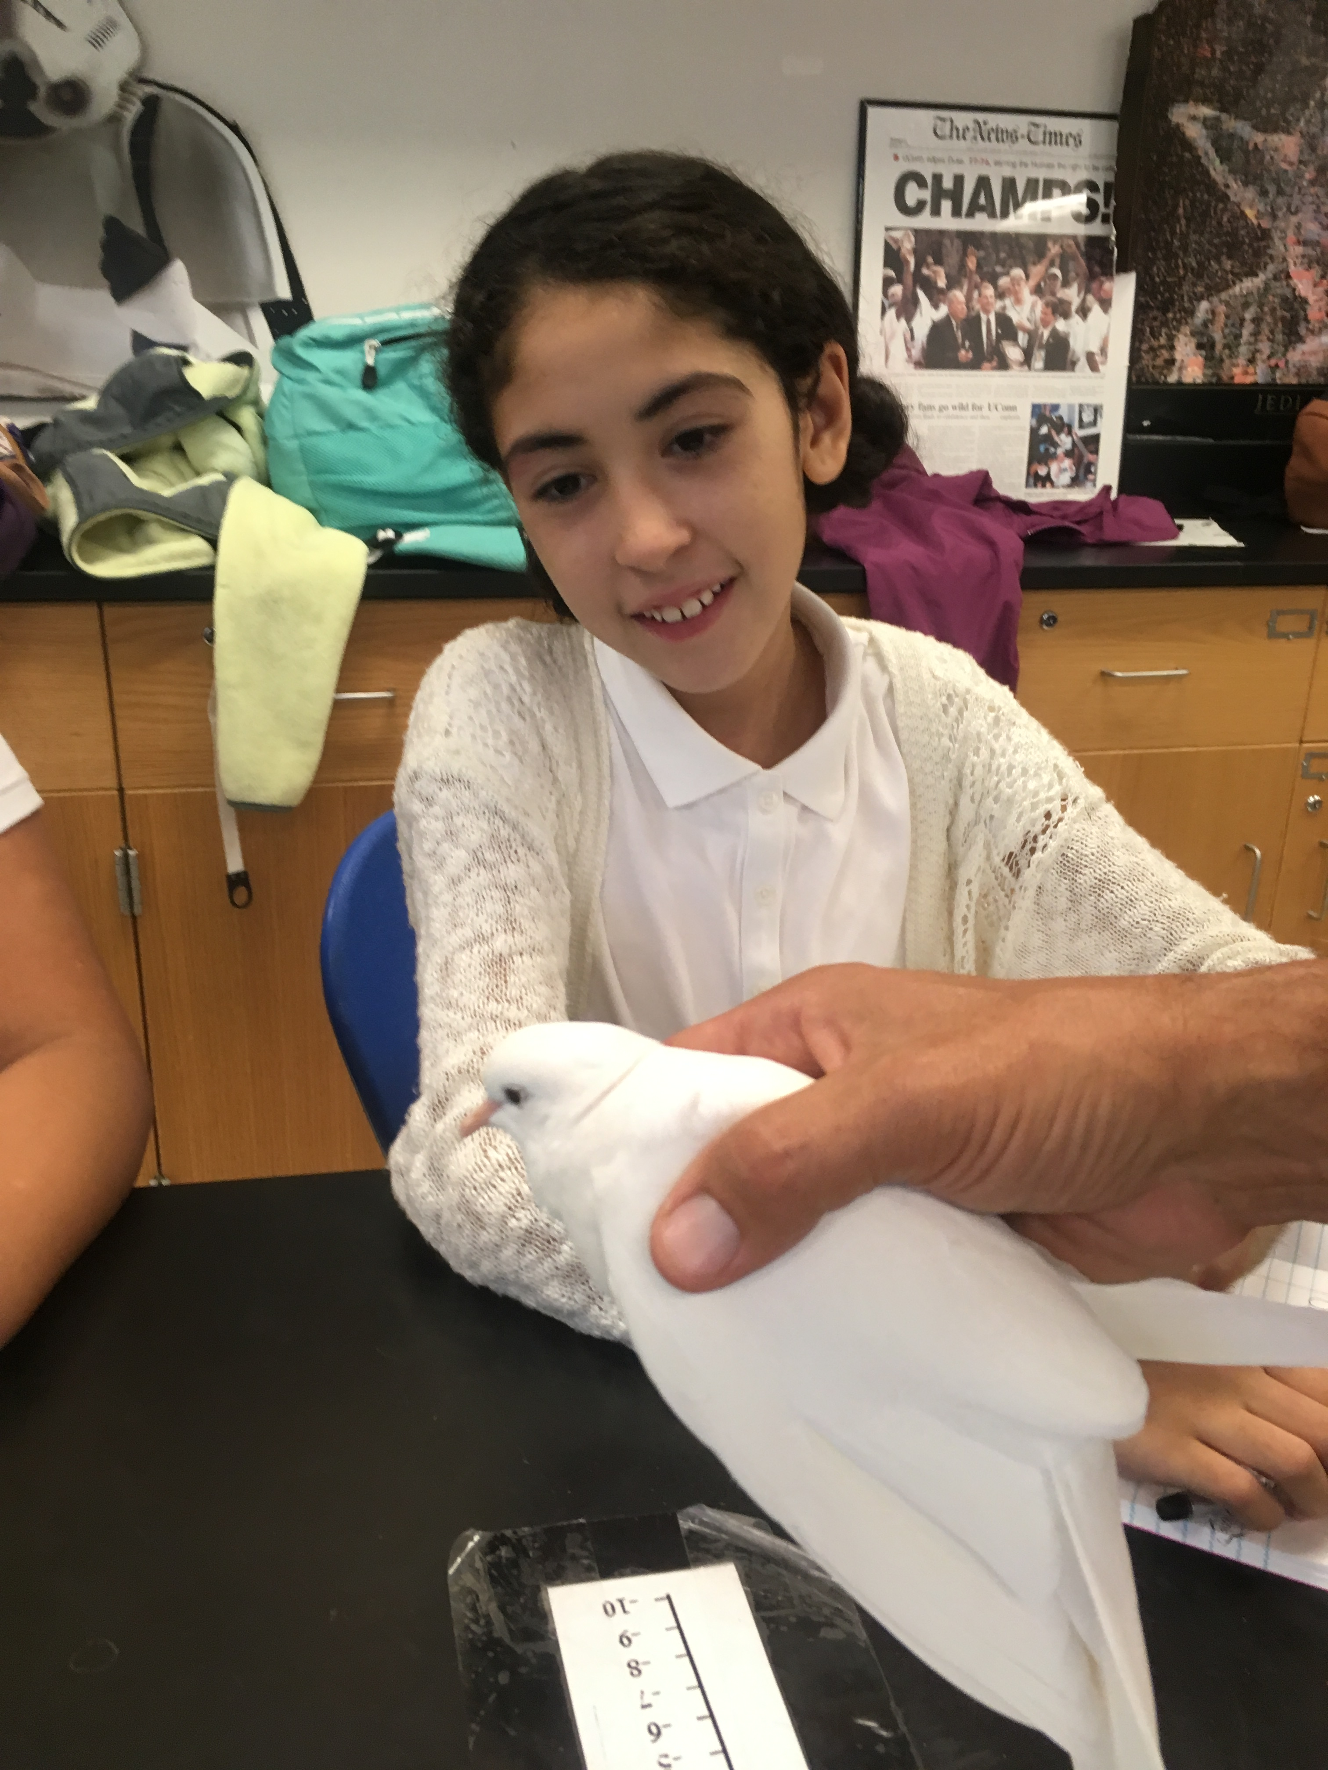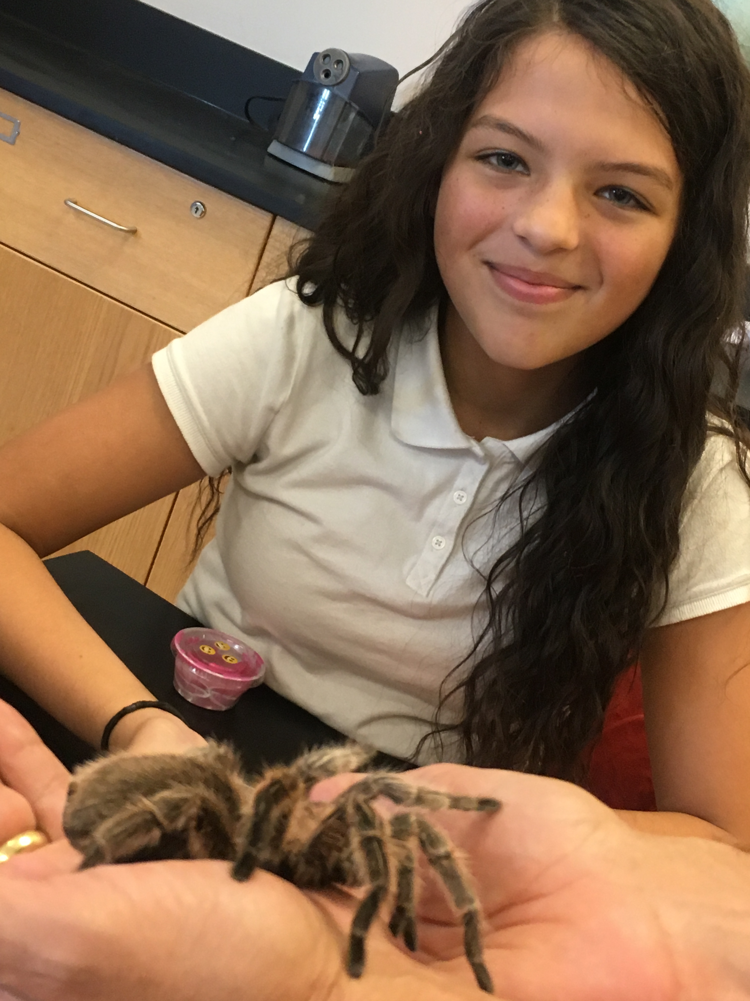

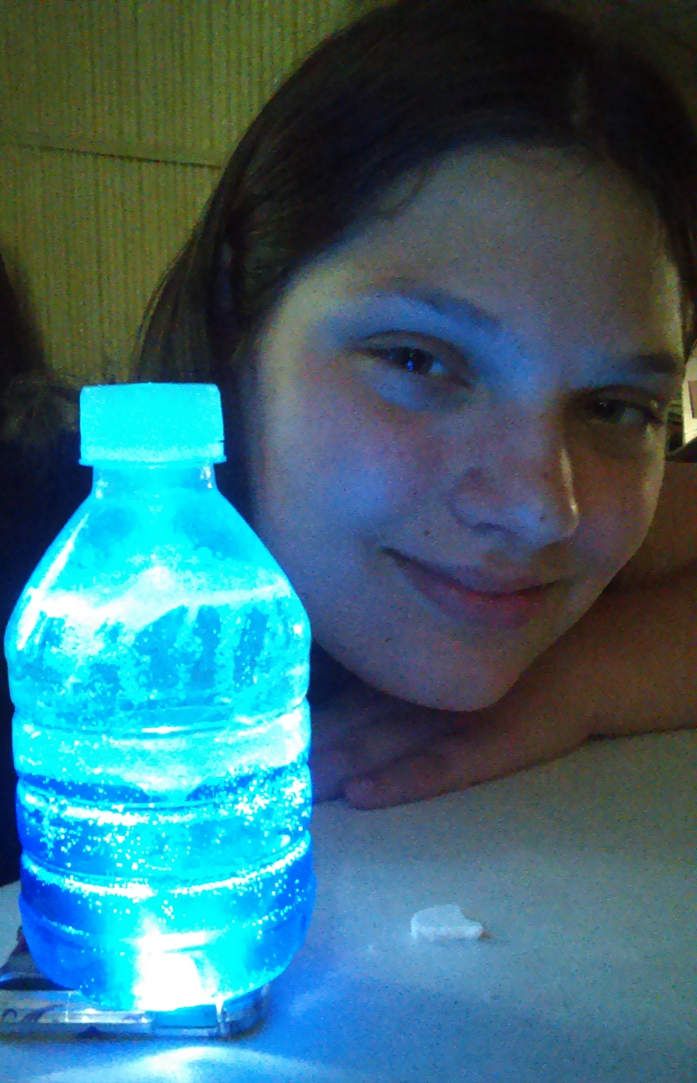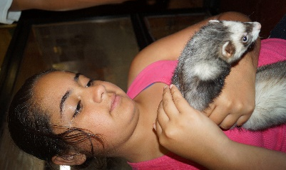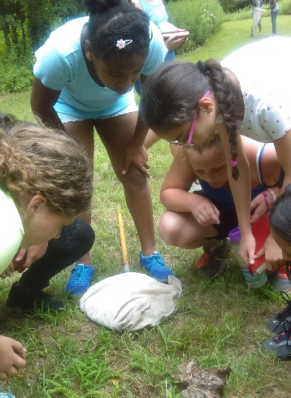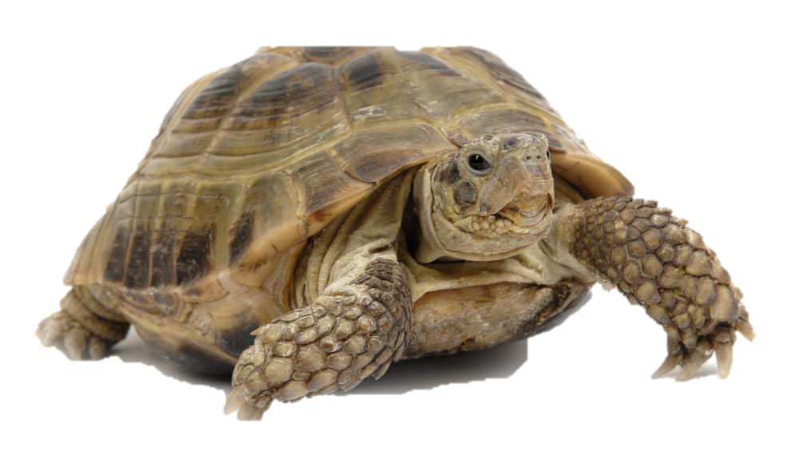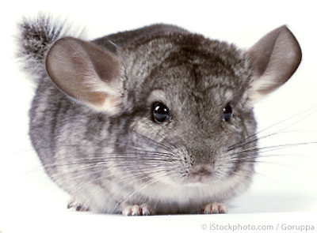
Must commit to 4 –Week program

Limited to 30 selected participants from
New Britain, Berlin and Southington
Entering 6th and 7th grades preferred
July 2nd to July 27th
No program on the 4th of July
9 a.m. - 2 p.m.
Early Drop-off starts at 8 a.m.
Late Pick-up by 2:30 p.m.
Must bring your own lunch
$100 Materials Fee (Non-refundable)
Stay active, develop new skills, explore the outdoors, work with live animals, do science experiment and more.

Transportation will NOT be provided.

IMPORTANT
For your child’s protection use sun block, bug spray or repellant lotion and sneakers are required as girls will be outdoors for part of the day. Water bottles daily and a towel to sit on the grass are strongly recommended.

For more information
New Britain Youth Museum call Lisette Velasquez (860) 225-3020
New Britain Youth Museum
Hungerford Nature Center
191 Farmington Ave., Kensington, CT 06037

Summer Sisters in Science 2018

Empowering our girls with STEM, nature & sisterhood!
Application Summer 2018
Full Student Name: __________________________________________Grade in the fall: _______
Full Home Address: ______________________________________________________________
Name of School: _________________________________________________ _______________
Ethnicity /Race: ___ Black/African-American ___ Native Hawaiian or Other Pacific Islander
____ Hispanic/Latino ___ African-American ____ Asian ___ White/European Ancestry
____ Bi-Racial _________________________________
Allergies/Medical Condition(s): _______________________________________________________
Special Needs/Concerns: ____________________________________________________________
Medication Needed: __ Yes __ No If so what is it? _______________________________________
Insurance Info: Provider _______________________________ Emergency Contact: _____________
_____ Photos/videos of my child can be taken and used by New Britain Youth Museum or media.
_____ Photos/videos cannot be taken of my child.
Parent(s) Name: ____________________________________________________________________
Phone: (home) _______________ (cell) ______________ (work) ______________ (other)__________
Parent e-mail: ______________________________________________________________________
In addition to parents listed above,
Child can be picked-up by: ______________________________________ Phone: _______________
______________________________________ Phone: _______________
______________________________________ Phone: _______________
Parent Signature: _______________________________________________ Date: _______________
I will commit to doing my best and working as a team at all times. ______________________________
(STUDENTS SIGNATURE)

